Cooking Club Lesson Plans:
Introduction to Cooking

https://www.kids-cooking-activities.com/kids-cooking-lessons-cit-3.html

Welcome to Cooking; Salsa

Icebreaker:

Materials: 6 Roma or garden tomatoes, green peppers, 1 jalapeño, seeded and roughly chopped, 1/2 large yellow or red onion (not sweet), peeled and roughly chopped, 3 cloves garlic, chopped or crushed, juice of 1 lemon or lime, 1 cup loosely packed fresh cilantro leaves, pinch of cumin (optional), 1/2 teaspoon sea salt, tortilla chips.

Message: Utensil Practice and Safety

How To: Cut and dice all vegetables. Mix in bowl with juice, salt and cilantro.

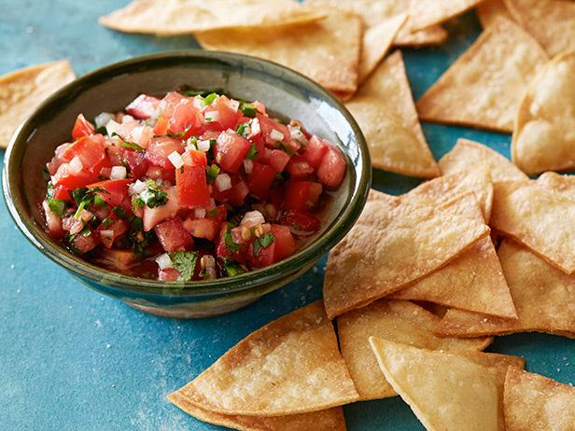

Omelets

Icebreaker: Two truths and a lie
Materials: 2 eggs, Sandwich Meat, Shredded Cheese, 2 tablespoons Milk, Vegetables, Parsley and other seasonings - Frying pan, spatula, stove top
Message: Practice Cracking Eggs
How To: Crack eggs into bowl, using a flat surface. Sometimes it is better to do one egg at a time in a measuring cup and pour into a bowl. Check for any shells in the cup. Stir in milk, chopped ham, cheese and vegetables. Blend together. Let adult cook in pan or supervise kids while they cook stirring back and forth in pan until cooked through.

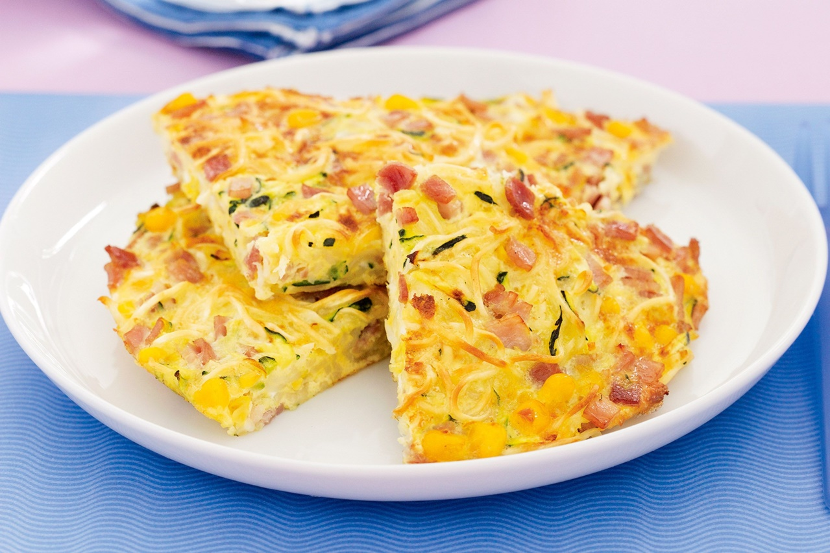

Waffle Iron Cinnamon Sticks

Icebreaker: Remember Me (Each member must remember a small fact about the last person and give one about themselves)
Materials: Pillsbury cinnamon roll dough, melted frosting, confectionary sugar, chocolate syrup, whipped cream, waffle iron (maybe ice cream)

Message: Kitchen Dangers; Heat Practice

How To: Heat and spray waffle iron. Arrange cinnamon roll dough close to center of iron. Let cook for 2-5 minutes or until ready. Take out and cut into tall pieces. Arrange in bowl with toppings.

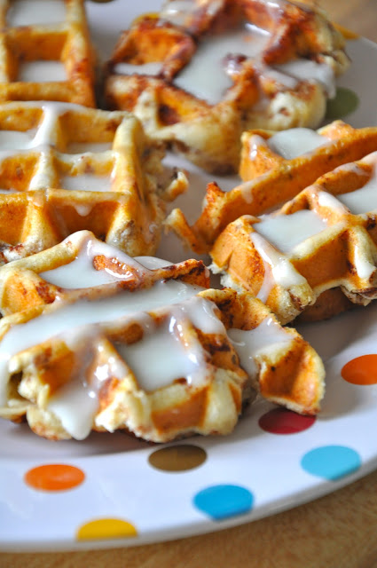
Quesadilla Bar

Materials: tortilla wraps, shredded cheese, onions, cooked chicken, onions, salsa, sour cream, olive oil, spatula,

Icebreaker:
Message: This self-serve meal lets kids load up open-faced quesadillas with their choice of toppings. For little kids: Let them assemble the quesadillas before baking. For big kids: Let them add the seasonings to the beef and help cut up the vegetables for the toppings.

How To: Preheat lightly oiled skillet, add tortilla with cheese on one side. As cheese melts, add other ingredient and more cheese. Close tortilla and flip. Brown and let cheese melt.

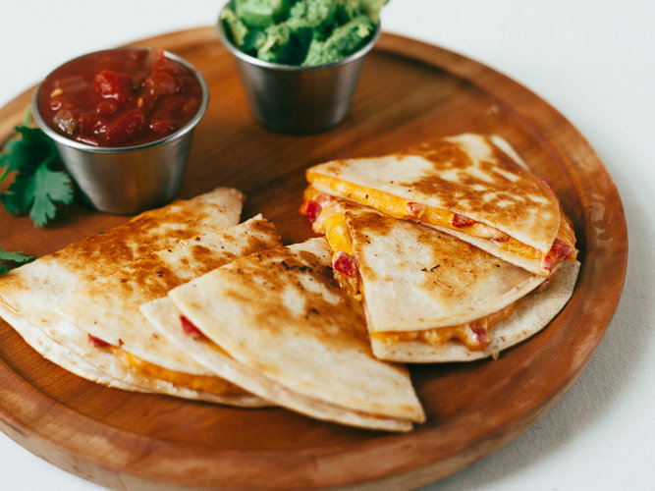
Alfredo Pasta

Materials: 3tablespoons sweet butter, 2tablespoons olive oil, 2garlic cloves, minced, 2cups heavy cream, ¹⁄₄teaspoon white pepper, ¹⁄₂cup grated parmesan cheese, ³⁄₄cup mozzarella cheese, 1(12 ounce) box angel hair pasta
Message: SUSTAINED ENERGY:
Carbohydrates like pasta provide glucose, the crucial fuel for your brain and muscles. Pasta is an excellent source of complex carbohydrates, which provide a slow release of energy. Unlike simple sugars that offer a quick, yet fleeting boost of energy, pasta helps sustain energy.
LOW SODIUM & CHOLESTEROL-FREE:
Pasta is very low in sodium and cholesterol-free. Per cup, enriched varieties provide a good source of several essential nutrients, including iron and several B-vitamins. Whole wheat pasta can provide up to 25% of daily fiber requirements in every one cup portion.
FOLIC ACID:
Enriched pasta is fortified with folic acid – essential for women of child-bearing age. FDA regulations require enriched grain products to contain this important vitamin. A serving of dry pasta supplies the equivalent of roughly 100 micrograms of folic acid, or 25% of the recommended daily intake.
BALANCED DIET:
Pasta is part of a well-balanced diet. Current dietary guidance calls for up to 65% of daily calories to come from carbohydrates, such as pasta.
How To:
- Melt butter in medium saucepan with olive oil over medium/low heat.
- Add the garlic, cream, white pepper and bring mixture to a simmer.
- Stir often.
- Add the Parmesan cheese and simmer sauce for 8-10 minutes or until sauce has thickened and is smooth.
- When sauce has thickened, add the Mozzarella cheese and stir until smooth. STIR FREQUENTLY.
- While the sauce cooks, boil noodles for 3-5 minutes.
- Place pasta on serving plates and spoon sauce over pasta.

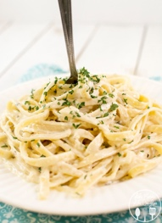

Breakfast; Waffles, Eggs, Bacon, Fruit Salad

Materials: whipped cream, turkey bacon, griddle, pancake mix, chocolate chips, eggs, milk, waffle maker, assorted fruit, butter, syrup

Icebreaker:

Message: Most important meal of the day, nutrition

How To:

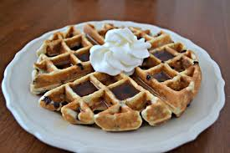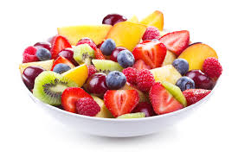

Brownie Belgium Waffle a la Mode

Materials: 1 1/2 cup all purpose flour, 1/2 cup unsweetened cocoa powder, 1 cup granulated sugar, 1 teaspoon baking powder, 1 teaspoon sea salt, 10 tablespoons melted unsalted butter, 2 large eggs, 2 teaspoons vanilla extract, 1/4 cup water, 2/3 cups mini chocolate chips, Optional Toppings: vanilla ice cream, chocolate sauce, powdered sugar

Icebreaker:

Message:

How To: 1. Preheat a Belgium waffle maker. In a large bowl mix the flour, cocoa powder, sugar, baking powder, and salt. Melt the butter and set aside to cool a little.
2. Beat the eggs, vanilla extract, and water in a small bowl. Whisk the egg mixture into the dry mixture, then quickly mix in the melted butter. Finally stir in the chocolate chips.
3. Spray the waffle iron with non-stick cooking spray. Pour one-third of the batter into the waffle iron, close and cook for approximately 3 minutes. Lift the lid to check the waffle. It should be fully formed, but soft to the touch. Carefully turn the waffle iron to flip the waffle out. The moment it starts cooling, it will crisp up. Repeat with the remaining batter.
4. Serve as-is, with powdered sugar on top, or “a la mode” with vanilla ice cream and chocolate sauce!

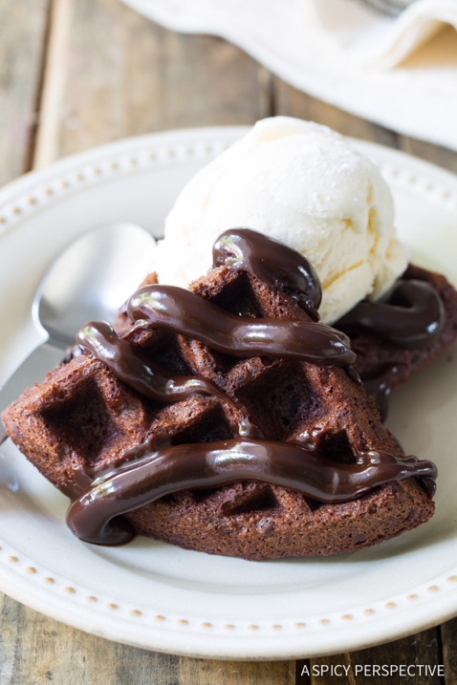

Salad Bar with Homemade Lemon Dressing

Materials: Salad stuff, 1/2 teaspoon finely grated lemon zest, 2 tablespoons freshly squeezed lemon juice, 1 teaspoon sugar, 1/2 teaspoon Dijon mustard, 1/4 teaspoon fine sea salt, or to taste, 3 to 4 tablespoons extra-virgin olive oil, freshly ground black pepper to taste.

Icebreaker:

Message:

How To: Blend ingredients, mix over personalized salads

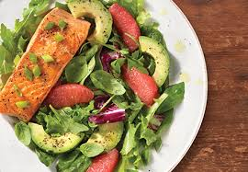
Mint and Fruit Smoothies

Materials: 1/4 cup red seedless grapes, frozen, 1/4 cup unsweetened applesauce, or to taste, 1 tablespoon fresh lime juice, 3 frozen strawberries, 1 cup cubed fresh pineapple, 3 fresh mint leaves
Icebreaker:

Message:

How To: Place frozen grapes, applesauce, and lime juice into a blender. Puree until smooth. Add frozen strawberries, cubed pineapple, and mint leaves. Pulse a few times until the strawberries and pineapple are in small bits.

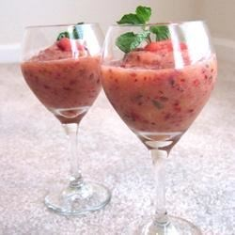

Awesome Waffle Grilled Cheese and Tomato Soup

Materials: 2 slices sandwich bread, 3 oz cheddar cheese, 2 tbsp salted butter, at room temperature, waffle iron

Icebreaker:

Message: Go, Slow and Woah

Go Foods- These are foods that are good to eat almost anytime. They are the healthiest ones. Example: skim and low-fat milk.

Slow Foods- These are sometimes foods. They aren't off-limits, but they shouldn't be eaten every day. At most, eat them several times a week. Example: waffles and pancakes.

Whoa Foods- These foods should make you say exactly that — Whoa! Should I eat that? Whoa foods are the least healthy and the most likely to cause weight problems, especially if a person eats them all the time. That's why Whoa foods are once-in-a-while foods. Example: French fries.

How To:
  - Preheat the waffle iron while you assemble the sandwiches.
  - Spread one slice of bread with butter, only on one side (this is the side that will have direct contact with the waffle iron).
  - Place the cheese slices on top of this slice of bread, then spread the other slice of bread with butter, only on one side.
  - Place the unbuttered side against the cheese, then place this entire sandwich on the waffle iron.
  - Close the top of the waffle iron, but do not press down and smash the sandwich.
  - Let this cook for 3-5 minutes until the bread is brown and crispy and the cheese has melted. Enjoy!

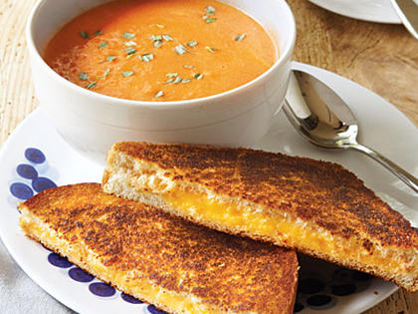

No-Bake Cheerio Snack Bars
https://www.averiecooks.com/2013/10/no-bake-honey-nut-cheerios-snack-bars.html#

Materials: 1/4 cup creamy unsalted butter (half of one stick), 1/4 cup honey (light-colored corn syrup may be substituted and will keep the bars firmer at room temp than using honey), 1/4 cup light brown sugar, packed
1 tablespoon vanilla extract, 3 cups Honey Nut Cheerios; plain Cheerios may be substituted for a less sweet bar) 1 cup raisins, optional (1 cup honey-roasted peanuts, 1 cup chopped almonds, or 1 cup trail mix may be substituted) about 1/2 cup chocolate-covered sunflower seeds, optional pinch sea salt or Kosher salt for sprinkling, optional

Message:

How To: Line an 8-inch square pan with aluminum foil leaving overhang, spray with cooking spray; set aside.

In a large microwave-safe bowl, combine butter, honey, brown sugar, and heat on high power for 1 minute to melt.

Stop to stir. Mixture will be on the granular side, this is okay.

Return bowl to microwave and heat for 1 more minute on high power. Stop to stir

Return bowl to microwave and heat for 1 more minute on high power. Stop to stir. On this third and final burst, mixture will become quite bubbly and foamy; use caution when removing from micro because this is boiling hot caramel and can cause burns.

Stir in the vanilla using caution because mixture could bubble up.

Stir in the cereal.

Stir in the optional raisins (or nuts).

Turn mixture out into prepared pan, packing it down firmly with a spatula and smoothing the top.

Optionally, sprinkle evenly with sunflower seeds and salt (the salt cuts some of the sweetness and I recommend it).

Cover pan with a sheet of foil (to prevent fridge smells), and place pan in fridge to set up for at least 2 to 3 hours, or overnight, or until bars are completely set before lifting out with foil overhang, slicing, and serving.

Bars will keep airtight in the refrigerator for up to 2 weeks, or in the freezer for up to 6 months. I recommend storing them in the fridge rather than room temp because they soften and get loose.

